
Year 10 - 2016

Investigation 2 In Class Section

Semester One Term 2

Probability

This investigation will be completed in class with help and guidance provided. You will then complete an in class validation, under test conditions to fully test your understanding of probability. No guidance or hints will be provided for this. You may use this in class section in the validation to help you. You may also have one other A4 note page.

AIM: In this assessment you will be investigating the results of two and three step chance experiments, assigning probabilities to outcomes and determining the probabilities of events.

Name: ______________________________________________ Class: __________________

Chef George wants to open a new restaurant and is considering running a special deal on a three course meal.
Soup (S), Main dish (M) and Dessert (D).

- If there is only one choice of soup (S), main dish (M) and dessert (D), how many complete meals are available?

Soup Main Dish Dessert Outcomes

Chicken (C) Apple pie (A) TCA

Tomato Soup (T)

Steak (S) Apple Pie (A) TSA

- Chef Gordon decides that an extra dessert of pavlova is now going to be on the menu. Draw the new tree diagram and list the possible outcomes.

Soup Main Dish Dessert Outcomes

- Using your tree diagram, what is the probability of choosing

- chicken for a main meal?

- choosing both tomato soup and pavlova?

- not choosing chicken?

- choosing apple pie, given someone will not eat it if they have steak.


Year 10 - 2016

Investigation 2 Validation

Semester One Term 2

Probability

This investigation will be completed in class under test conditions to fully test your understanding of probability. No guidance or hints will be provided for this. You may use the in class section and any other A4 note page to in the validation to help you.
Calculators are allowed.
Time allocation 50 minutes.

AIM: In this assessment you will be investigating the results of two and three step chance experiments, assigning probabilities to outcomes and determining the probabilities of events.

Name: ______________________________________________ Class: __________________ Mark: /22

1. [4, 2, 2, 2 = 10]
Nikki can get to school by bus, by car or walk. She can get home from school either by bus, by train, by car or walk. If she walks to school, then she will take a bus home. If she takes a bus to school, then she will walk home.

- Draw a tree diagram to show the different ways Nikki can travel to school and back home (from school). Label your diagram clearly.

- Assume that each combination of mode of travel to and from school is equally likely.
- Find the probability that on any given day, she travels to school by car.

- Find the probability that on any given day, she walks home from school.

- Find the probability that on days when she gets to school by car, she takes a train home.

2. [4, 2, 2, 2, 2 = 12]
Draw a tree diagram for the information given below:

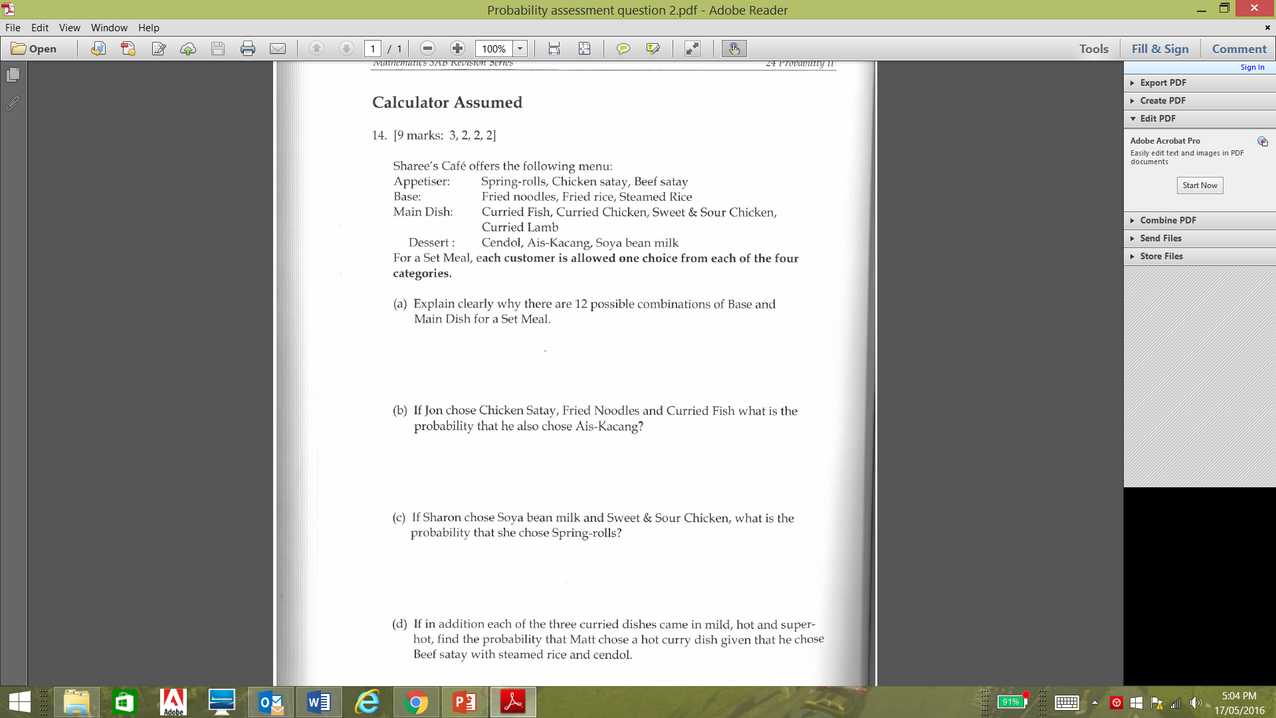

- Explain clearly why there are 12 possible combinations of Base and Main Dish for a set meal.

- If Jon chose Chicken Satay, Fried Noodles and Curried Fish, what is the probability that he also chose
Ais-Kacang?

- If Sharon chose Soya bean milk and Sweet & Sour Chicken, what is the probability that she chose Spring-rolls?

- If, in addition, each of the three curried dishes came in mild, hot and super-hot, find the probability that Matt chose a hot curry dish given that he chose Beef Satay with Steamed Rice and Cendol.

END OF INVESTIGATION

